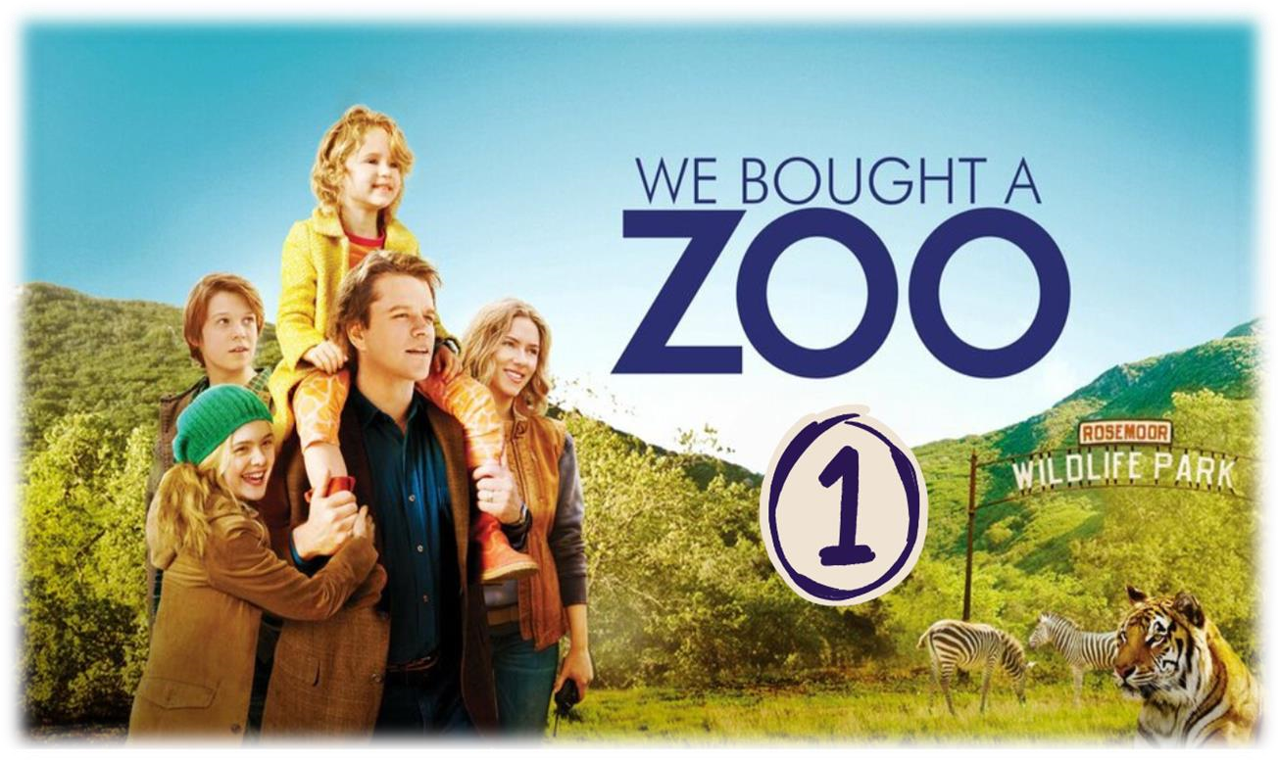

MOVIE BACKGROUND



Movie Background: Do your research to have an idea about the movie in terms
of:

- Date: December 2011
- Place: California , USA
- Main Characters: Benjamin Mee ( father ) , Dylan Mee ( son ) , Rosie Mee ( daughter ) , Ducan Mee ( Benjamin’s brother )

WORK ON SCENE 01

Scene summary:

Benjamin was a journalist who loved adventure but his wife passed away six months ago making him responsible for his children Dylan and Rosie . Although he started taking care of them, he has not yet adapted to the situation. However, his older brother was always there for him and advised him to start over .

Scene Discussion & Analysis:
- Q01: What does Benjamin Mee do for a living?
- Benjamin Mee is a journalist he writes adventure .
- Q02: What does he look like?
- Rate the beauty ( handsome – ugly- cute – pretty – beautiful - good-looking )
- Color of the skin ( Light skin – fair skin - dark skin )
- Age ( young – middle aged – teenager – old )
- Nationality ( Algerian – Chinese )
- Gender ( man – boy – girl – woman )
- Size : (Slim / thin) –Fit – ( Curvy – chubby – fat )
- Height : short – medium height – tall
- Hair : Length ( long – short – medium length ) – nature ( straight – curly – wavy ) – color ( brunette – blond – chestnut )
- Eyes : shape ( big – small ) – color ( dark eyes – light eyes …… )
- Mustache - beard – glasses – bald – tattoo ( other features )
- He is a handsome , fair skinned , middle aged man . He is fit and tall . He has short straight chestnut hair and small light eyes .
- Q3: What is he like? (first impression)
- He is a caring father who loves his kids . He is responsible and interested in adventure and he is so courageous .
- Q04: Is she married?
- No , he is not . He is a widower .
- Q05: How many children does he have?
- He has two children . One son and one daughter .
- Q06: What do they look like?
- Dylan is good looking , light skinned , young boy . He is fit and medium height . He has medium length straight and chestnut hair . He had big dark eyes .
- Rosie is beautiful , light skinned , young girl . She is slim and short . She has long straight blond hair . She has big dark eyes .
- Q07: Does his brother look younger than him?
- No , he does not
- Q08: Does his brother seem supportive?
- Yes , he does .
- Q09: What was his brother’s advice? Raise
He advised him to attempt to start over .
Acquired Vocabulary (OPTIONAL):

► Pernicious (adj):
  - Example in a sentence:

« The pernicious effect of smoking on health are well documented and can lead to serious long term deceases .
► The ins and outs:
  - Example in a sentence:
After year , I understand the ins and outs of my job .
► To let some sunlight in (metaphor) ➢ Example in a sentence:
I decided to let some sunlight in by focusing on the positives in my life .
Irregular Verbs:

Infinitive | Past simple | Past participle
To know | Knew | Known
To think | Thought | Thought
To get out | Got out | Gotten out
To let | Let | Let

ADDITIONAL EXERCISE (OPTIONAL)

Task: Transcribe sentences from the scene.

► Transcribe Sentence 01
Look I am the one who gets the emails about your lack of efforts, man Okay . You either know where the book is or you don’t .
► Transcribe Sentence 02
Causing insidious harm or ruin , causing damage “
► Transcribe Sentence 03 get to
“ Human interaction is a good thing . Take it from a guy who spent six months on a commercial fishing boat in Bali trying to find himself, remember that!

WHAT I STRUGGLED WITH? (OPTIONAL)

.... .... .... .... .... .... ..... .... .... .... .... .... ..... .... .... ....
.... .... ..... .... .... .... .... .... ..... .... .... .... .... .... ..... ....
.... .... .... .... ..... .... .... .... .... .... ..... .... .... .... .... ....
..... .... .... .... .... .... ..... .... .... .... .... .... ..... .... .... .... .... .... ..... .... .... .... .... .... ..... .... .... .... .... .... ..... ....
.... .... .... .... ..... .... .... .... .... .... ..... .... .... .... .... ....
..... .... .... .... .... .... ..... .... .... .... .... .... ..... .... .... .... .... .... ..... .... .... .... .... .... ..... .... .... .... .... .... ..... ....
.... .... .... .... ..... .... .... .... .... .... ..... .... .... .... .... ....
..... .... .... .... .... .... ..... .... .... .... .... .... ..... .... .... .... .... .... ..... .... .... .... .... .... ..... .... .... .... .... .... ..... ....
.... .... .... .... ..... .... .... .... .... .... ..... .... .... .... .... ....
..... .... .... .... .... .... ..... .... .... .... .... .... ..... .... .... ....
.... .... ..... ........ .... ..... .... .... .... .... .... ..... .... .... ....
.... .... ..... .... .... .... .... .... ..... .... .... .... .... .... ..... ....
.... .... .... .... ..... .... .... .... .... .... ..... .... .... .... .... ....
..... .... .... .... .... .... ..... .... .... .... .... .... ..... .... .... ....
.... .... ..... .... .... .... .... .... ..... .... .... .... .... .... .....

